**Apresentações - elementos:**

Part III (3 pessoas, 2 minutos cada) - DFG (Da Fucking Goat)

Part IV (3 pessoas, 2 minutos cada) -

Final pitch (todos, 3 minutos cada)

(<https://fenix.tecnico.ulisboa.pt/disciplinas/EITT/2021-2022/2-semestre/ver-post/about-the-final-pitch> )

**5 key topics:**

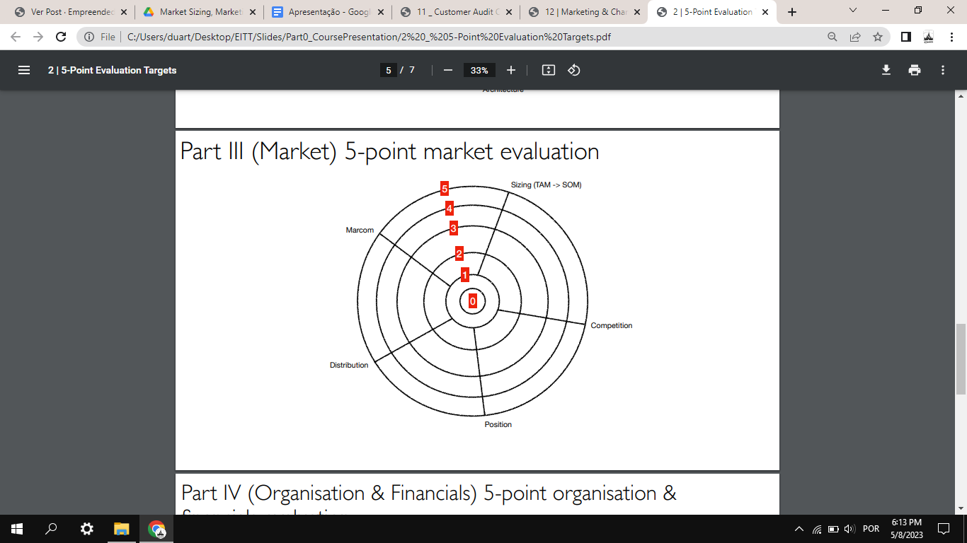

1. Market sizing - Gonçalo

Basically, this is where you have to define your market (i.e. who is going to buy/use your product/service). The 2 main sizes of the market are TAM and SAM, respectively Total Available Market and Serviceable Available Market. These can be obtained on the internet, mainly on market research websites (e.g. statista.com and many others). Typically, TAM and SAM are defined in €€€€ or $$$$, but they can also be determined in terms of population. It is well known that typical venture capital investors expect startups to address a market value of more than $1 billion which gives a good indication of the growth potential of a startup. Market values of this size are expected from startups that are global by design, never from startups that only address a small home market such as Portugal.

Presentation 8 in Part III of the slide collection on Fenix gives you ample information regarding the methods and sources of information that are usually employed to determine market sizing. Presentation 10 gives you additional information about market sizing.

1. Competition - Duarte - ver ficheiro Docx “Competion and Positioning”

This is where you have to discuss the other products/services that you have identified close to your product/service. It is not enough to say just that company ABC is a competitor, you have to be able to discuss what company ABC does and how that compares to what your startup project does. This is where you have to have your product/service very well defined and described (Part II) so that you have very objective data to support your assessment of the competition. All companies have competition, all companies must be able to clearly define what their competitive advantages are to win in the market.

Competition and positioning are closely related, together they should be able to determine how competitive your startup can be and how it will be able to win.

1. Positioning - Duarte

This results directly from competition in the sense that by knowing well your competition and how you are going to compete you are then able to define what your position in the market should be.

Presentation 10 in Part III of the slide collection on Fenix gives you ample information on competitive advantages and market differentiation.

1. Distribution - Fábio

This is basically how you are going to get the product/service that your startup sells to your customers in the market.

1. Market communications (marcom) - Fábio

This is basically how you are going to be known in your market, i.e. how your target market and customers know you exist and what you sell.

Presentation 12 in Part III of the slide collection on Fenix gives you ample information on the techniques that are most often used to let the market know our startup exists and how we bring products/services to the market.

For example:

1. one entrepreneur researches and studies market sizing

2. one entrepreneur researches and studies competitive, differentiating, and positioning aspects

3. one entrepreneur looks at distribution

4. one entrepreneur looks at marketing

5. the remaining entrepreneurs can keep working on the design and development of the engineering part of your product/service which will only be finished at the end of the semester.

**Distribution**

We are aware of the seasonal problem of this industry. For the shipping, after having the pieces assembled:

* Online
  + In-house logistics
  + Outsourcing
    - Since it is seasonal this is one of the best alternatives
* Retail
  + This is also one of the alternatives

**Macrom**

[**Marketing for the toy industry isn’t all fun and games | Startups Magazine**](https://startupsmagazine.co.uk/article-marketing-toy-industry-isnt-all-fun-and-games)

* Focus on creating an emotional connection: Toys are often associated with happy childhood memories, so it's essential to create a strong emotional connection with consumers. Use storytelling and relatable characters to create a bond with the target audience.
* Leverage influencers (content creators): Influencer marketing is proving to be an effective way to promote toys, particularly via YouTube and TikTok. Build relationships with influencers who have a strong following within your target demographic to create authentic and engaging content.
* Use data to inform marketing strategies: Collect and analyse data to gain insights into consumer behaviour and preferences. Use this information to create targeted marketing campaigns that reach the right audience with the right message.
* Create engaging content: Use video and interactive content to showcase the features and benefits of your toys. Create compelling product demonstrations and unboxing videos to generate excitement and interest.
* Build relationships with retailers: Toy manufacturers need to work closely with retailers to ensure their products are prominently displayed and marketed effectively. Build relationships with key retail partners and work collaboratively to create marketing campaigns that drive sales.
* Create memorable experiences: Use experiential marketing to create memorable experiences for consumers. Host events, create pop-up shops, and create interactive displays that allow consumers to engage with your products in fun and unique ways.
* Digital advertising: Technology has made it possible to reach a wider audience through digital advertising, including social media, influencer marketing, and online video platforms. Toy marketers can use these platforms to create targeted campaigns that reach specific demographics and showcase products in engaging and interactive ways.
* Interactive and augmented reality toys: Technology is enabling the creation of more interactive and immersive toys, including those that incorporate augmented reality (AR) and virtual reality (VR) technologies.
* Online shopping: Online marketplaces and toy retailers are leveraging technology to create more personalised shopping experiences, including product recommendations, user-generated reviews, and customized promotions.
* Social media engagement: Toy marketers are increasingly using social media to engage with consumers and build brand awareness. Social media platforms provide a direct line of communication between marketers and consumers, allowing them to respond quickly to feedback and create a more personalized experience.

Client Acquisition Cost (CAC): average of 10$ for toys’r us:   
<https://hotcopper.com.au/documentdownload?id=uOMxKKzFkiWRTLKhOROKAxjvSTYP6gu9wBCZtPhgke92GA%3D%3D>

CAC for e-commerce 68$ and for entertaining 106$:

[Average Customer Acquisition Cost (CAC) by Industry: B2C Edition (firstpagesage.com)](https://firstpagesage.com/seo-blog/average-cac-by-industry-b2c-edition/)

CAC for hardware 182$:

[Customer Acquisition Cost by Industry | CAC Benchmarks (startuptalky.com)](https://startuptalky.com/cac-by-industry/)

Link interessante:

[The Serious Business Of Play | TechCrunch](https://techcrunch.com/2016/02/15/the-serious-business-of-play/?guccounter=1&guce_referrer=aHR0cHM6Ly93d3cuZ29vZ2xlLmNvbS8&guce_referrer_sig=AQAAAH3TfKRJielN2MEIIWy6JcDqdf2qT5_iqXyg6eXt73Uu4erMHpZLTHERxyuUCBXOcoJsmF943LCSw_hXnDy74BZ6dzCeSWQ1rC86qZOjJQ9qDAPyb1hnK2C-d0E80J6JBO0MPdrhledw4_klFMbYX_EtGHBZaAPJNOLO18Rr8nzm)

Depois da reunião:

**ACQUISITION COST**

The customer acquisition cost is the price tag associated with [converting a potential customer into a buyer](https://blog.powr.io/converting-customers-into-buyers-5-effective-ecommerce-tips?hsLang=en). This could include advertising, marketing, sales, and any other fees associated with acquiring customers. For ecommerce businesses, CAC can be a bit more complex than traditional brick-and-mortar businesses because there are more touch-points involved in the [customer journey](https://debutify.com/blog/7-ways-to-create-an-ecommerce-customer-journey-map/).

The average CAC in ecommerce depends on the industry you’re looking at.

<https://blog.powr.io/the-average-cost-of-customer-acquisition-in-ecommerce>

<https://seowithdavid.com/average-customer-acquisition-cost-for-ecommerce/>



As for the average customer acquisition cost in e-commerce, [data by ChatterBuzz](https://www.chatterbuzzmedia.com/blog/calculate-customer-acquisition-cost/) puts a median estimate using Google Paid Search campaigns at $45.27. Naturally, this figure will differ based on the type of product you’re selling as an e-commerce store. [Data compiled by Propeller](https://www.propellercrm.com/blog/customer-acquisition-cost) has found that average customer acquisition cost by industry stands thus:

* **Consumer Goods (can include items such as food, beverages, clothing, recreation items (e.g., toys), electronics and appliances (e.g., televisions)): $22**

### How to reduce your customer acquisition cost?

### Continuously modify your customer acquisition strategy

#### Focus on your website’s accessibility for better conversions

#### Cut costs

#### Find low-cost niches

#### Cut down on your sales cycle

#### Retain your customers

<https://blog.converted.in/en-us/blog/average-customer-acquisition-cost-in-ecommerce>

### 

**DISTRIBUTION AND ARMAZENAMENTO COMPANY**

TIBA Portugal - <https://www.tibagroup.com/pt/logistica-distribuicao-armazenagem>

#### [**ARMAZÉM DE E-COMMERCE**](https://www.tibagroup.com/pt/logistica-ecommerce)

A [solução One-Stop-Shop de e-commerce](https://www.tibagroup.com/pt/logistica-ecommerce) é global e abrange várias indústrias em toda a cadeia de abastecimento. Gerimos atualmente mais de 5.000 referências em stock e oferecemos soluções competitivas totalmente personalizadas ou padronizadas de acordo com suas necessidades. Soluções para várias dimensões de operação.

Só entregas nacionais, porém! (tambem Espanha, Argelia e Mexico)

Não encontrei valores em Portugal…

<https://www.bain.com/insights/are-your-distribution-and-transportation-costs-out-of-control/>

Distribution and transportation:

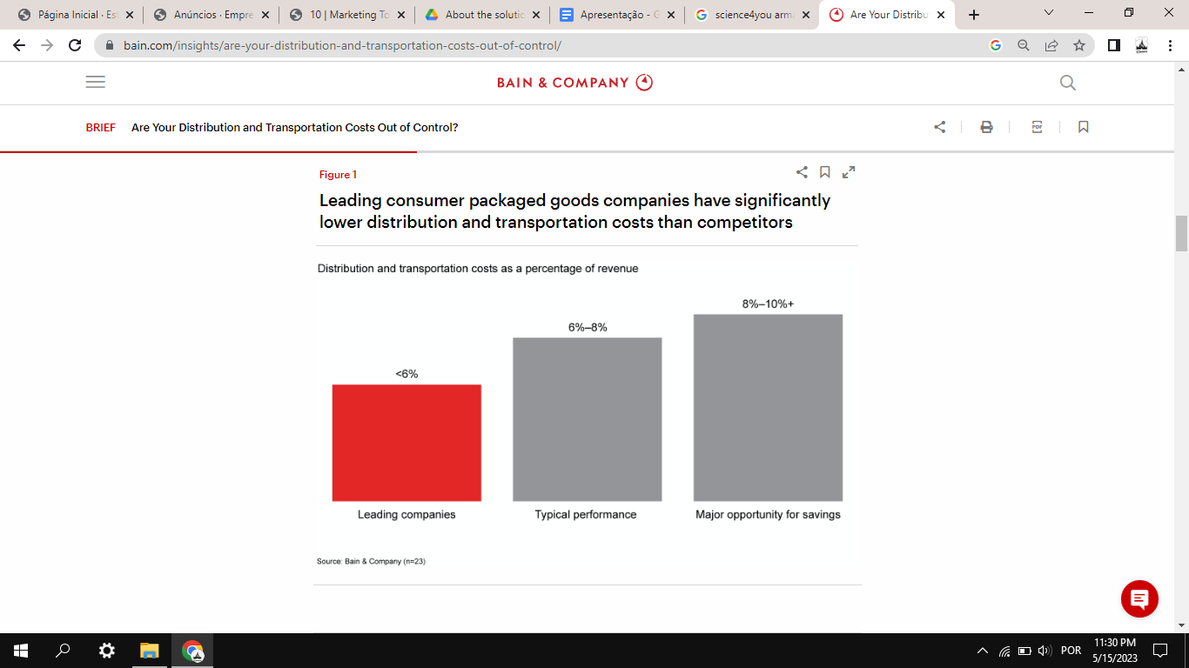

Storage:

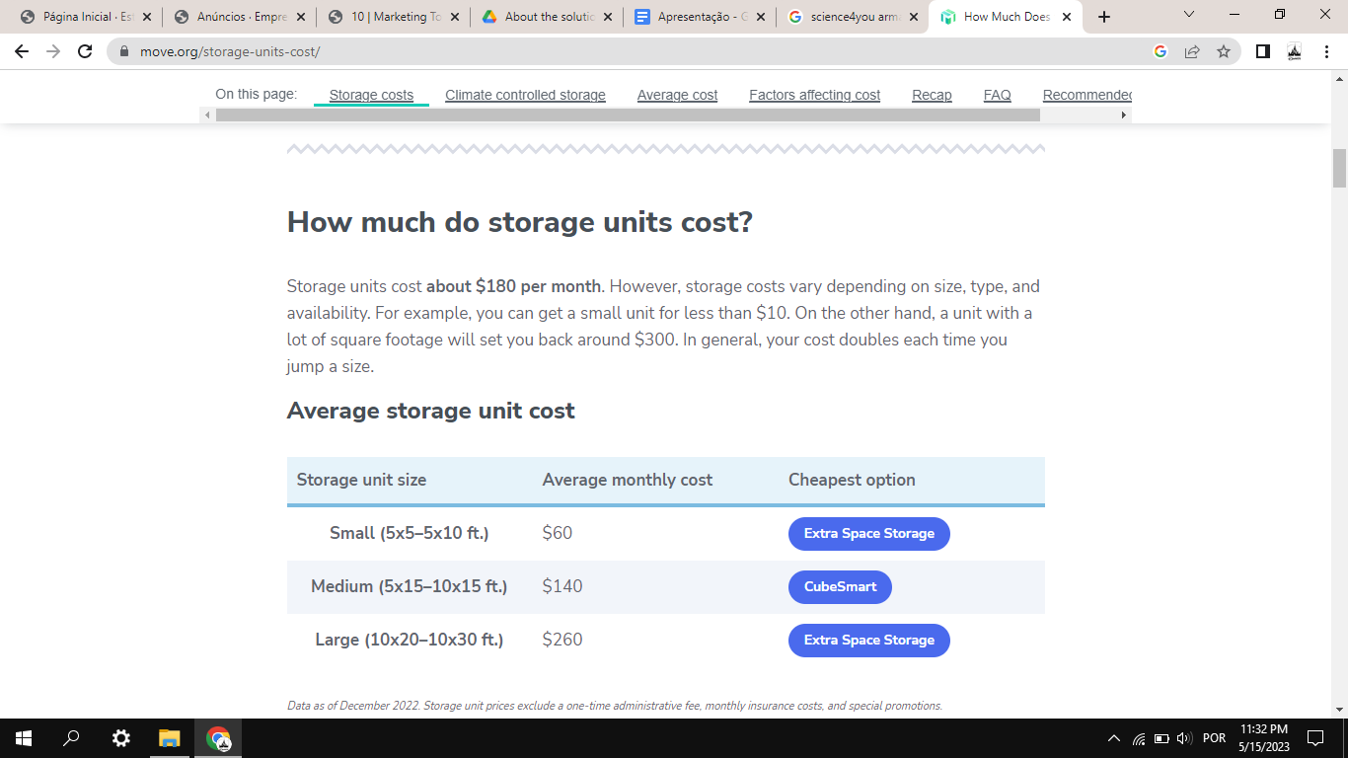

**QUOTAS DE ONLINE SELLING**

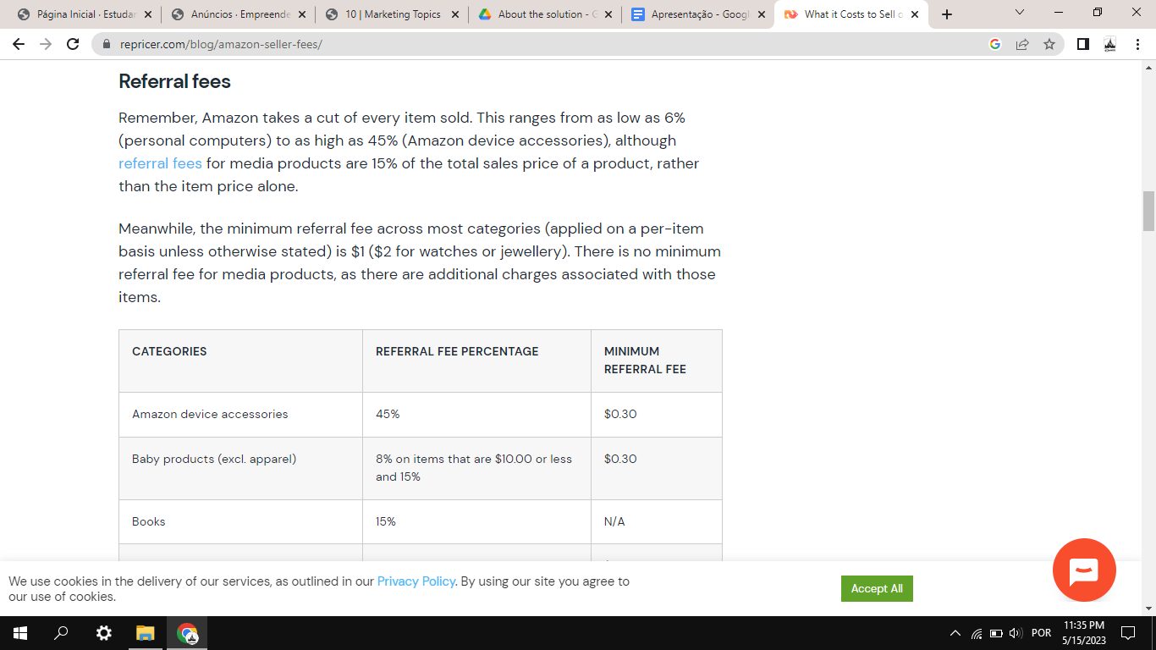

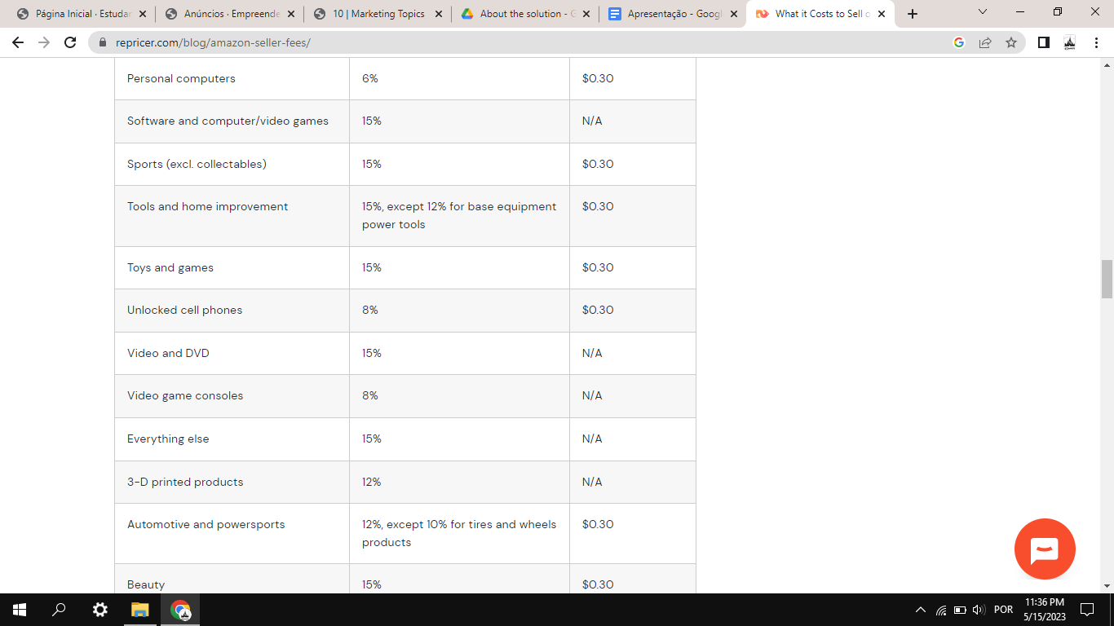

#1. Monthly subscription fee: Professional sellers (selling more than 40 items a month) pay $39.99 a month.

+

#4. Referral fees: Sellers pay a referral fee on each item sold. Items in several categories have a per-item minimum referral fee, so sellers pay the referral fee or the per-item minimum fee, whichever is more.

Bastante caro, daí a vantagem de vendermos no nosso website…